

**Sadaf Iqbal**

**56352**

**SE-03**

**COAL LAB**

**LAB # 09**

**TASK # 01**

.model small

.stack 100h

.data

msg1 DB 10,13, "Enter First Number A: $"

msg2 DB 10,13, "Enter Second Number B: $"

msg3 DB 10,13, "A is greater than B$"

msg4 DB 10,13, "A is less than B$"

.code

main proc

mov ax, @data

mov ds, ax

mov dx, offset msg1

mov ah, 9

int 21h

mov ah, 1

int 21h

sub al, '0'

mov cl, al

mov dx, offset msg2

mov ah, 9

int 21h

mov ah, 1

int 21h

sub al, '0'

mov dl, al

cmp cl, dl

jg Greater

jl Less

Greater:

mov dx, offset msg3

mov ah, 9

int 21h

mov ah,4ch

int 21h

Less:

mov dx, offset msg4

mov ah, 9

int 21h

mov ah,4ch

int 21h

main endp

end main

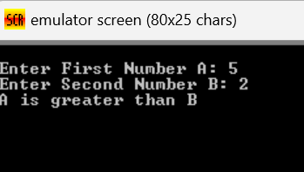

**TASK # 02**

.model small

.stack 100h

.data

msg1 DB 10,13, "Enter a one-digit number: $"

msg2 DB 10,13, "The number is zero$"

msg3 DB 10,13, "The number is positive$"

.code

main proc

mov ax, @data

mov ds, ax

mov dx, offset msg1

mov ah, 9

int 21h

mov ah, 1

int 21h

sub al, '0'

cmp al, 9

cmp al, 0

cmp al, 0

je IsZero

mov dx, offset msg3

mov ah, 9

int 21h

mov ah,4ch

int 21h

IsZero:

mov dx, offset msg2

mov ah, 9

int 21h

mov ah, 4Ch

int 21h

main endp

end main

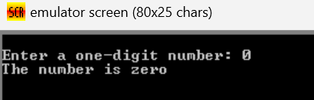

**Task # 03**

.model small

.stack 100h

.data

msg1 DB 10,13, "Enter your marks in lab mid: $"

msg2 DB 10,13, "Need hard work$"

msg3 DB 10,13, "Satisfactory$"

.code

main proc

mov ax, @data

mov ds, ax

mov dx, offset msg1

mov ah, 9

int 21h

mov ah, 1

int 21h

sub al, '0'

mov cl, al

cmp cl, 5

jl Less

mov dx, offset msg3

mov ah, 9

int 21h

mov ah,4ch

int 21h

Less:

mov dx, offset msg2

mov ah, 9

int 21h

mov ah, 4Ch

int 21h

main endp

end main

